SPRINT 3

Date | 17 Nov 2022
Team ID | PNT2022TMID48083
Project Name | CUSTOMER CARE REGISTRY

Forgot Password:

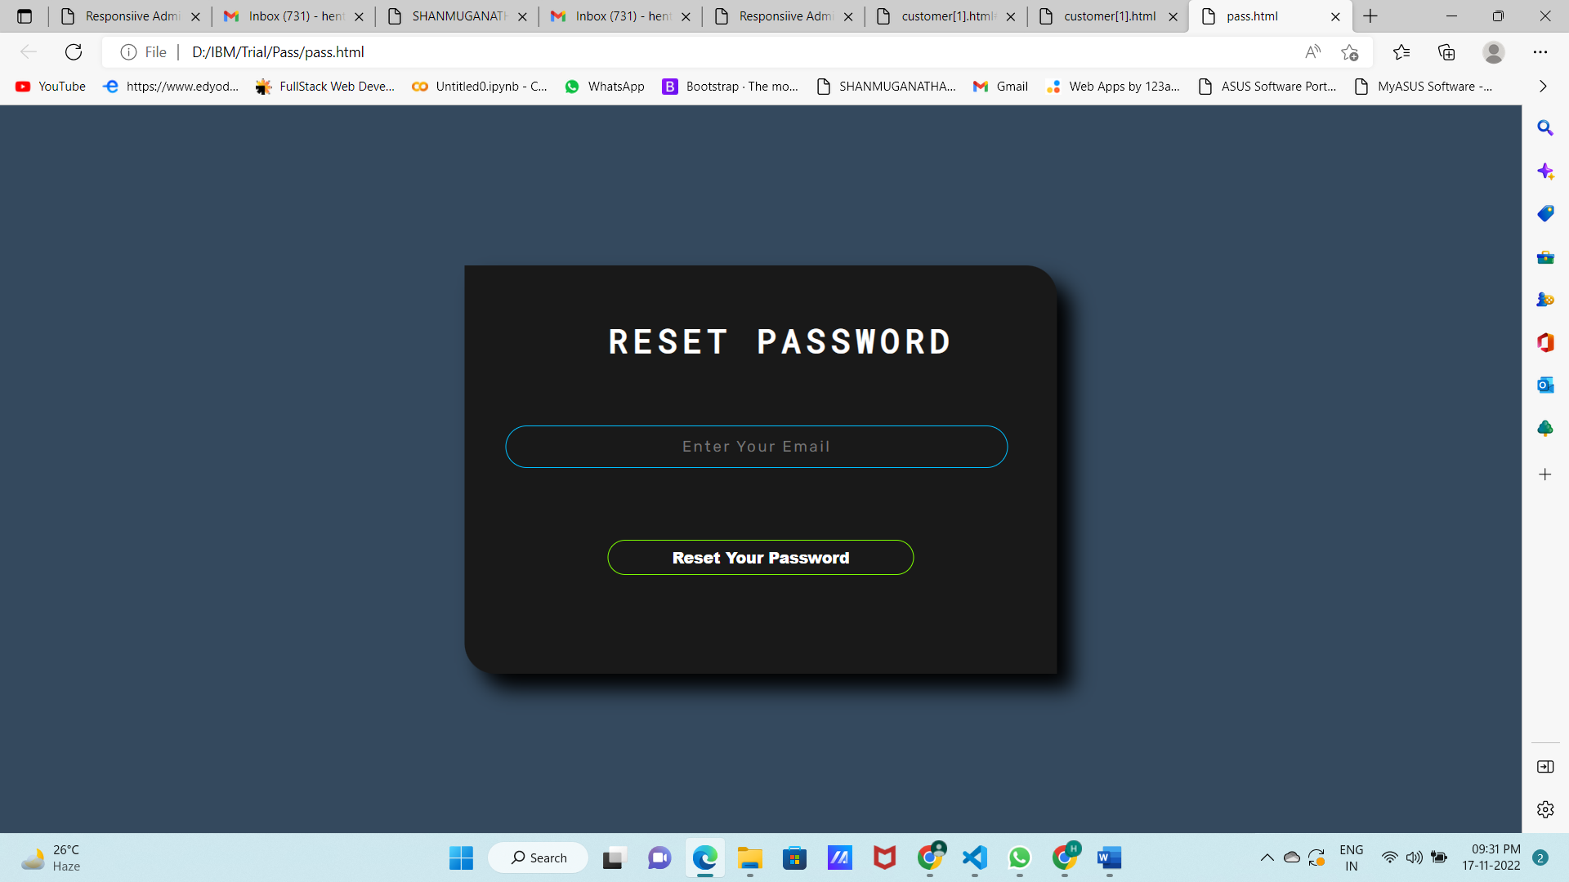

Agent Forgot Password:

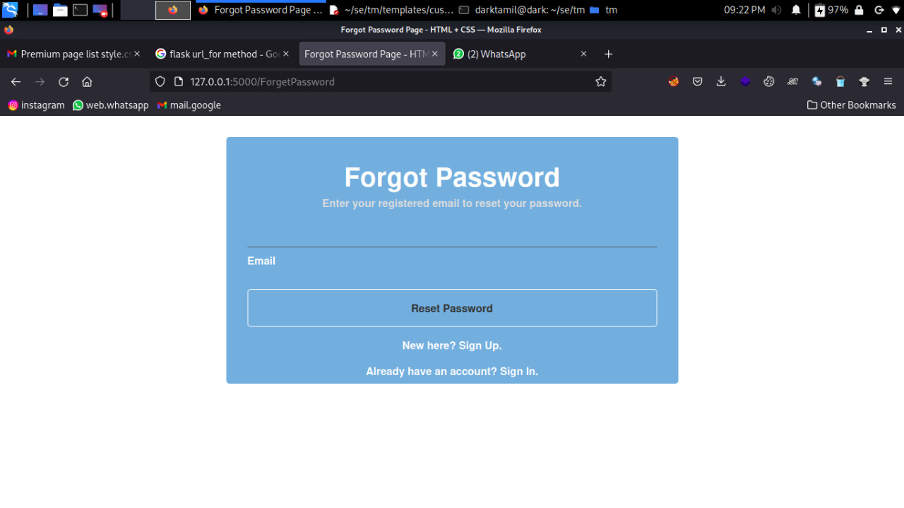

Customer Forgot Password:

